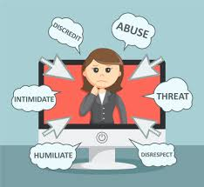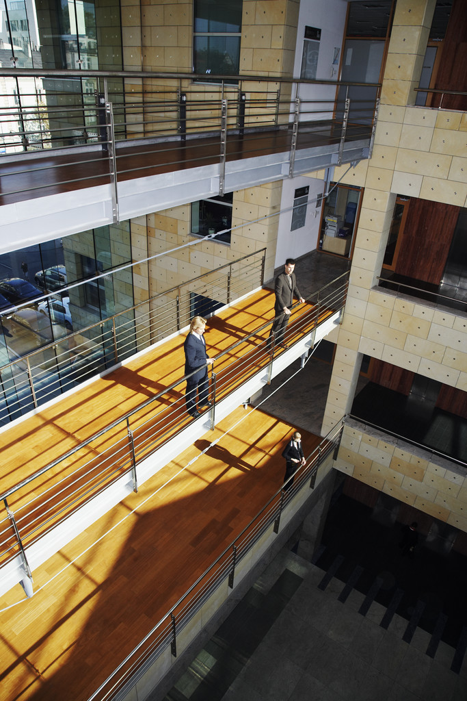

We are seeking contributions relevant to the scope outlined below. Article/empirical research, conceptual papers or reviews are welcomed.

Deadline for submissions: 28 February 2021

.

Instructions for authors can be found here <https://www.mdpi.com/journal/societies/instructions>

GUEST EDITORS

Dr. Margaret Hodgins

Professor Patricia Mannix McNamara

Special issue of ‘Societies’ Journal

**Challenging Assumptions about Bullying and Incivility: The Importance of Strong Ethical Climate**

Call for contributions

*Societies* Special Issue

*Concerns about rudeness, incivility, abrasive and disrespectful behaviour are commonly articulated, and not without cause. At least one quarter of adults report experience of incivility either as an employee or as a customer, or just in the street. Hostile and humiliating behaviour is not only tolerated but is feted, even glorified, on reality TV shows that celebrate the humiliation and rejection of others. Societal appetite for such denigration has become voracious, and is now practically de rigueur for reality television and on social media channels. Sexual harassment in public spaces is widespread and often normalised, frequently reinforced by cultural values which celebrate a hypermasculinity. Abuse has become alarmingly normalised.*

*It is little surprise then, that bullying, harassment and incivility are pervasive problems in today’s workplaces. Incivility refers to verbally abusive behaviour with ambiguous intent regarding harm to the target. The normalisation of bullying and harassment in workplaces is well documented in the literature, with little if any solutions offered. It is linked to other ‘normalisations’ such as the normalisation of entitlement, i.e., the entitlement to exercise power, even when that exercise borders on brutal behaviour, or manifest as coercive control, and/or the common normalisation as ‘tough’ management.*

*Bullying in voluntary organisations, (i.e., organisations founded on the basis of a civic good), is relatively understudied, yet there has been some alarming evidence of normative abuse in such organisations, which society has heretofore considered to have been moral cornerstones. Recent decades have seen the disintegration of societal confidence in organisations previously held in collective regard for their civic, ethical and spiritual leadership due to exposures of inordinate abuse, bullying and harassment that has wreaked havoc on people’s lives.*

*This Special Issue aims to explore the normalisation of incivility, hostility, harassment and bullying in wider society and in particular in workplaces with a view to understanding the origins and motivations behind societal deterioration where abuse and humiliation of others has become acceptable, or worse still, where it has become desired entertainment.*

*We argue that these behaviours stem from a culture that permits abusive behaviour to be enacted and where redress has become utopian, despite the proliferation of policy and legislation to the contrary. We consider all negative behaviours that travel under the banner of bullying, harassment incivility and ill-treatment to be inherently unethical. We are interested in ethical climate and how this can be recovered so that the dignity of human beings and indeed of society itself can flourish. Papers are invited across the range of ideas contained here and explorations of what ethical climate looks like in workplaces and wider afield; submissions addressing how ethical climates are created and maintained are particularly invited.*

The deadline for manuscript submissions is **28 February 2021**, and instructions for authors can be found here <https://www.mdpi.com/journal/societies/instructions>